AMRITA UNIVERSITY INSPIRED WEBSITE
Project Documentation
Submitted By
Name: S. Siva karthikeya
Roll Number: AV.SC.U4CSE25050
Course: USER INTERFACE DESIGN
Department: SCHOOL OF COMPUTING
Institution: AMRITA

ABSTRACT
The purpose of this project is to design and develop a responsive university website inspired by the Amrita University website using HTML, CSS, and JavaScript. The website provides information regarding courses, admissions, placements, events, campus facilities, and contact details.
The project aims to demonstrate modern frontend web development concepts while maintaining a beginner-friendly implementation. The website is designed with a clean user interface, responsive layouts, multiple pages, and interactive features.
The project also focuses on improving user experience through navigation systems, form handling, animations, and mobile responsiveness. This project helped in understanding website development, UI design, and deployment using GitHub Pages.

1. INTRODUCTION
A university website serves as an important platform for providing academic and institutional information to students, parents, faculty members, and visitors.
The objective of this project is to create a university website that resembles the structure and functionality of a modern educational institution website.
The website contains information about:
- University overview
- Courses offered
- Admission process
- Placement activities
- Events and announcements
- Contact details
- Campus information
The website has been developed using only HTML, CSS, and JavaScript without using external frameworks.
This project helped in understanding the complete frontend development process, from designing the user interface to deploying the website online.
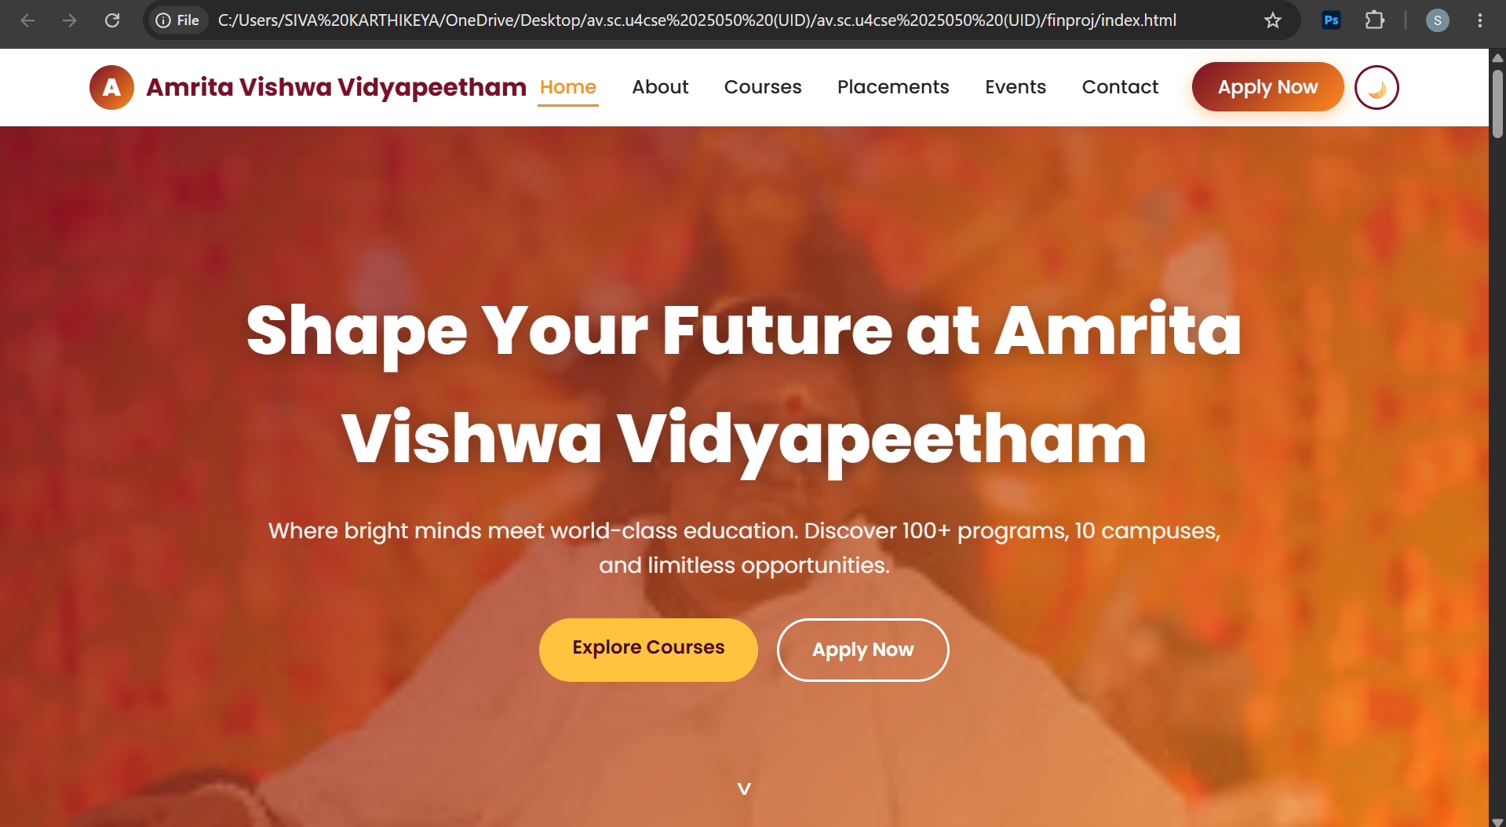

2. OBJECTIVES
The primary objectives of this project are:
- To develop a responsive university website.
- To apply HTML, CSS, and JavaScript concepts.
- To learn modern frontend development practices.
- To create multiple interconnected web pages.
- To improve user experience through responsive design.
- To implement interactive features using JavaScript.
- To understand project organization and deployment.
- To host the website using GitHub Pages.
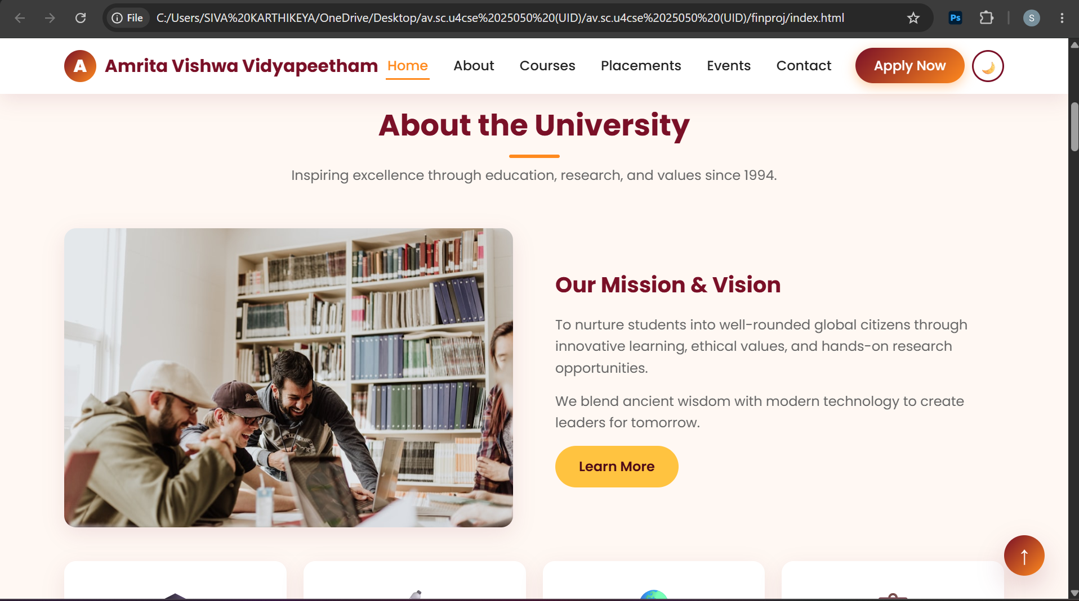

3. TECHNOLOGIES USED
HTML5
HTML5 is used to create the structure and content of the website. It provides semantic elements that improve readability and maintainability.
Examples:
- Header
- Navigation Bar
- Sections
- Forms
- Footer
CSS3
CSS3 is used for designing and styling the website.
Features implemented:
- Flexbox
- CSS Grid
- Media Queries
- Hover Effects
- Gradients
- Animations
- Responsive Layouts
JavaScript
JavaScript is used to make the website interactive.
Features implemented:
- Mobile menu toggle
- Form validation
- Counter animations
- Smooth scrolling
- Event handling
- User interaction
GitHub
GitHub is used to:
- Store source code
- Manage project versions
- Share the project online
- Deploy the website using GitHub Pages
- 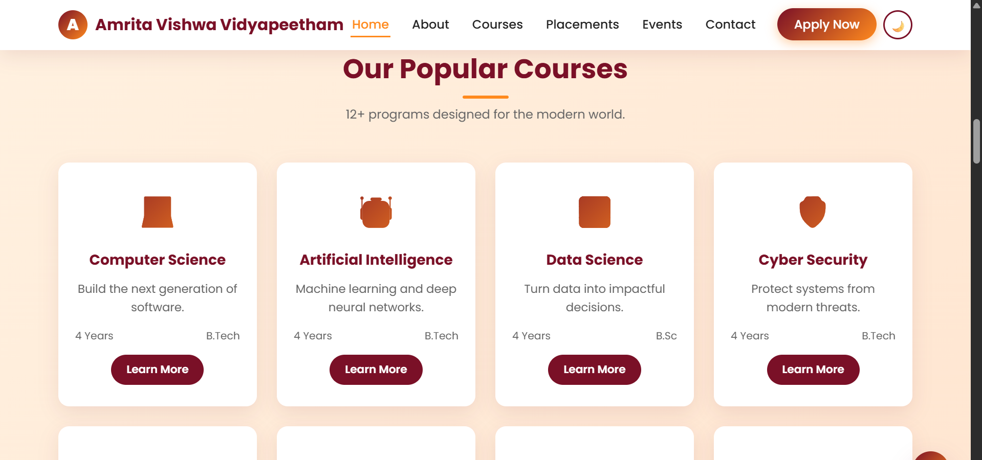

4. PROJECT STRUCTURE
The project follows a well-organized folder structure.
Project Folder
index.html
about.html
courses.html
placements.html
events.html
contact.html
apply.html
style.css
script.js
images
The HTML files represent individual pages of the website.
The CSS file manages the appearance and responsiveness of the website.
The JavaScript file controls the interactive features.
The images folder stores all media resources used in the project.
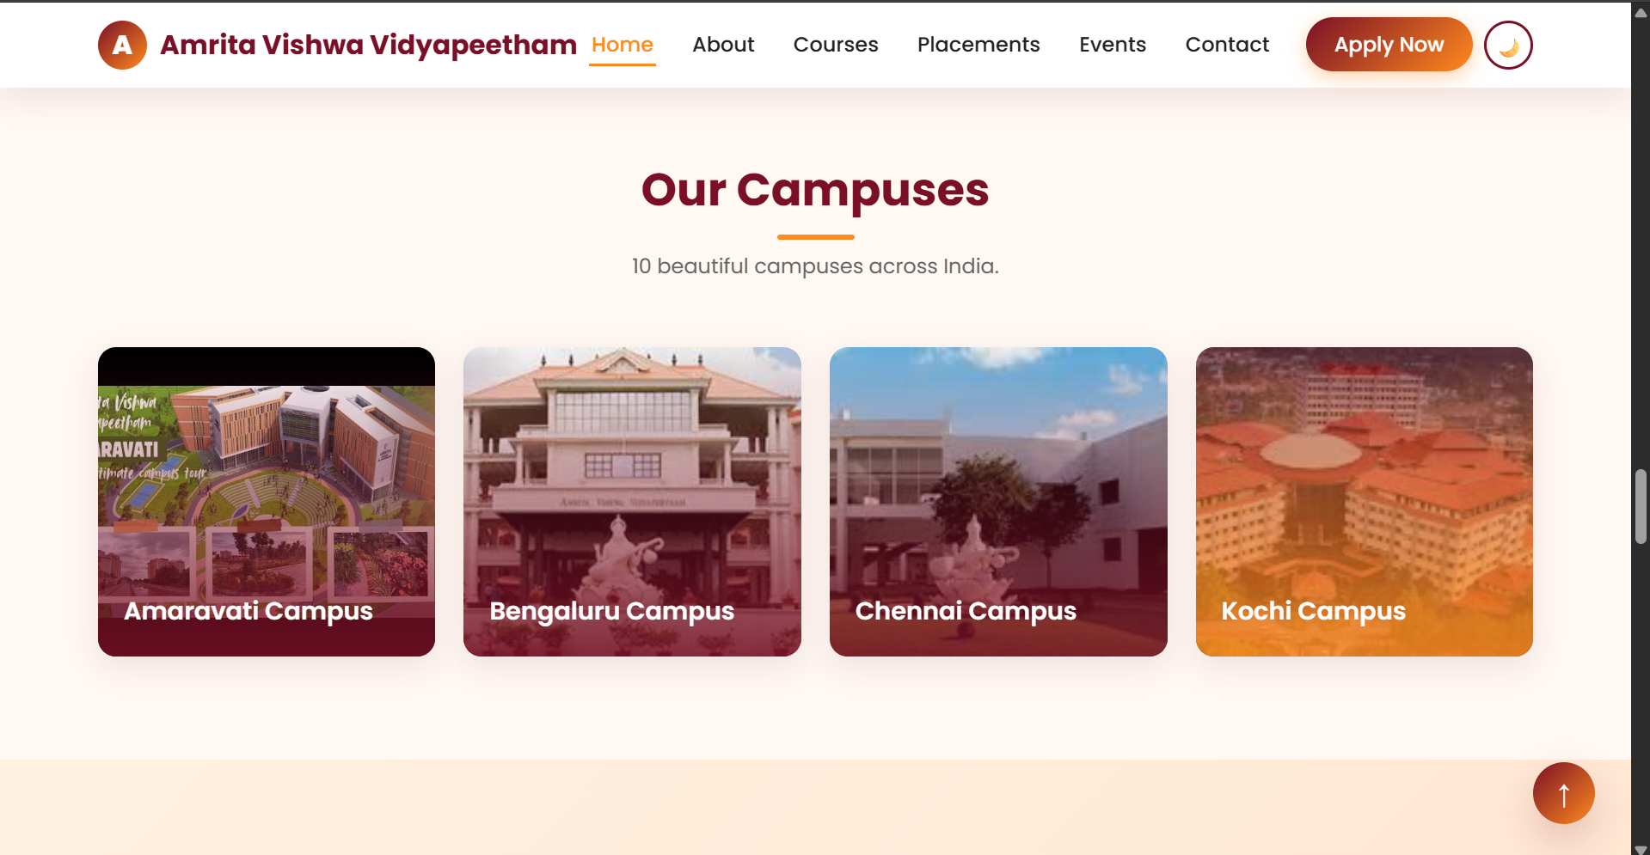

5. WEBSITE FEATURES
Home Page
The homepage contains:
- Navigation bar
- Hero section
- University introduction
- Highlights and achievements
- Call-to-action buttons
About Page
The About page includes:
- University history
- Vision and mission
- Achievements
- Institutional information
Courses Page
The Courses page displays various programs such as:
- Computer Science Engineering
- Artificial Intelligence
- Data Science
- Cyber Security
- Mechanical Engineering
- MBA
- Biotechnology
Each course is displayed using attractive cards.
Placements Page
The placements section contains:
- Placement statistics
- Recruiter information
- Student success stories
Events Page
The events page displays:
- Workshops
- Seminars
- Technical festivals
- Academic events
Contact Page
The contact page provides:
- Contact information
- Address
- Email
- Contact form
Apply Page
The Apply Now page allows students to submit admission details through an online application form.
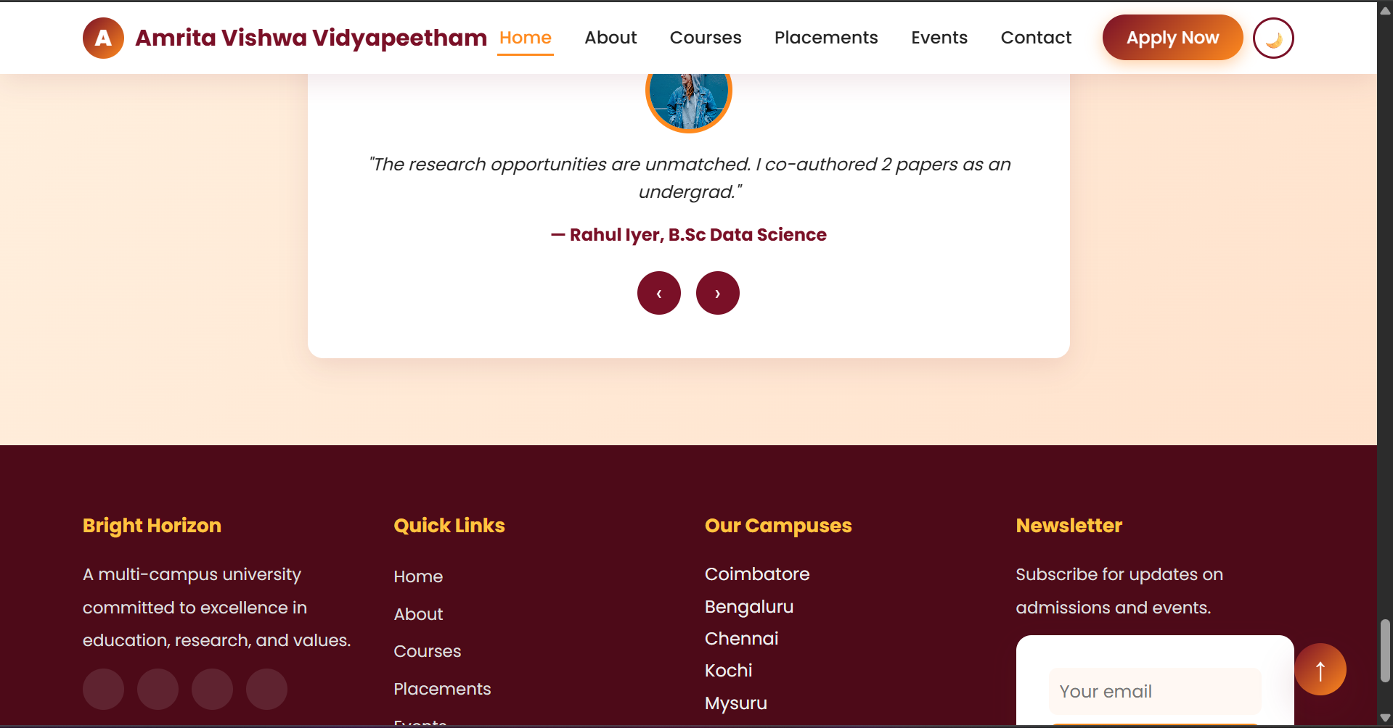

6. NEW CONCEPTS LEARNED
This project helped in learning several modern web development concepts.
Responsive Web Design
Responsive design ensures that the website functions properly on mobile phones, tablets, and desktop computers.
CSS Flexbox
Flexbox was used to:
- Align content
- Create navigation bars
- Organize layouts
CSS Grid
CSS Grid was used to:
- Display course cards
- Arrange image galleries
- Create structured layouts
DOM Manipulation
DOM stands for Document Object Model.
Using JavaScript, the DOM allows:
- Accessing HTML elements
- Modifying content
- Handling user interactions
Event Handling
JavaScript event listeners were used to:
- Detect button clicks
- Validate forms
- Control navigation menus
GitHub Deployment
The project was deployed using GitHub Pages, making it accessible through a public URL.
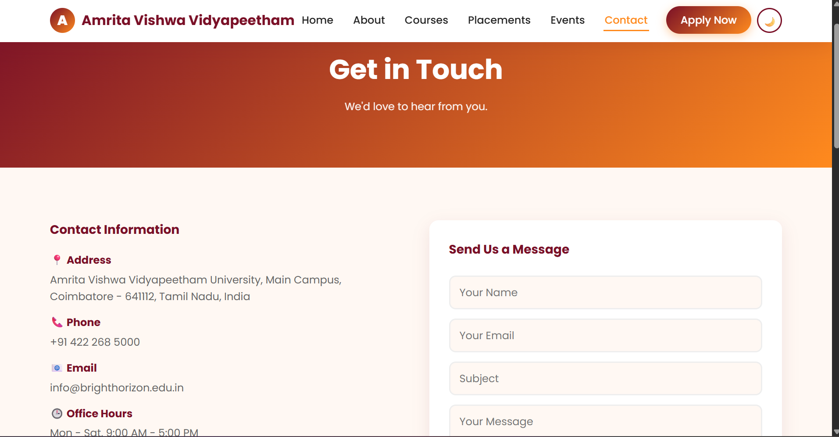

7. IMPLEMENTATION DETAILS
The website was developed using a step-by-step approach.
Step 1:
Created the HTML structure for all pages.
Step 2:
Applied CSS styling to improve the user interface.
Step 3:
Added responsiveness using media queries.
Step 4:
Implemented JavaScript functionality.
Step 5:
Tested the website on different screen sizes.
Step 6:
Uploaded the project to GitHub.
Step 7:
Published the website using GitHub Pages.
This systematic approach helped ensure that the project remained organized and easy to maintain.

8. CHALLENGES FACED
During the development process, several challenges were encountered.
- Designing responsive layouts.
- Managing multiple pages.
- Ensuring consistent styling.
- Connecting navigation links correctly.
- Implementing JavaScript interactions.
- Organizing project files effectively.
These challenges were solved through testing, debugging, and continuous improvement.

CONCLUSION
The Amrita University Inspired Website project successfully demonstrates the application of HTML, CSS, and JavaScript in developing a modern and responsive educational website.
The project helped in understanding frontend development concepts such as Flexbox, CSS Grid, Responsive Design, DOM Manipulation, and GitHub Deployment.
The website provides an attractive user interface, multiple pages, and interactive features while maintaining simplicity and ease of use.
Overall, the project enhanced practical web development skills and provided valuable experience in designing and deploying modern websites.

REFERENCES
- HTML5 Documentation
- CSS3 Documentation
- JavaScript Documentation
- GitHub Documentation
- Responsive Web Design Resources
- Amrita University Website (Reference Design)

